***Orientierungs training*** Name:  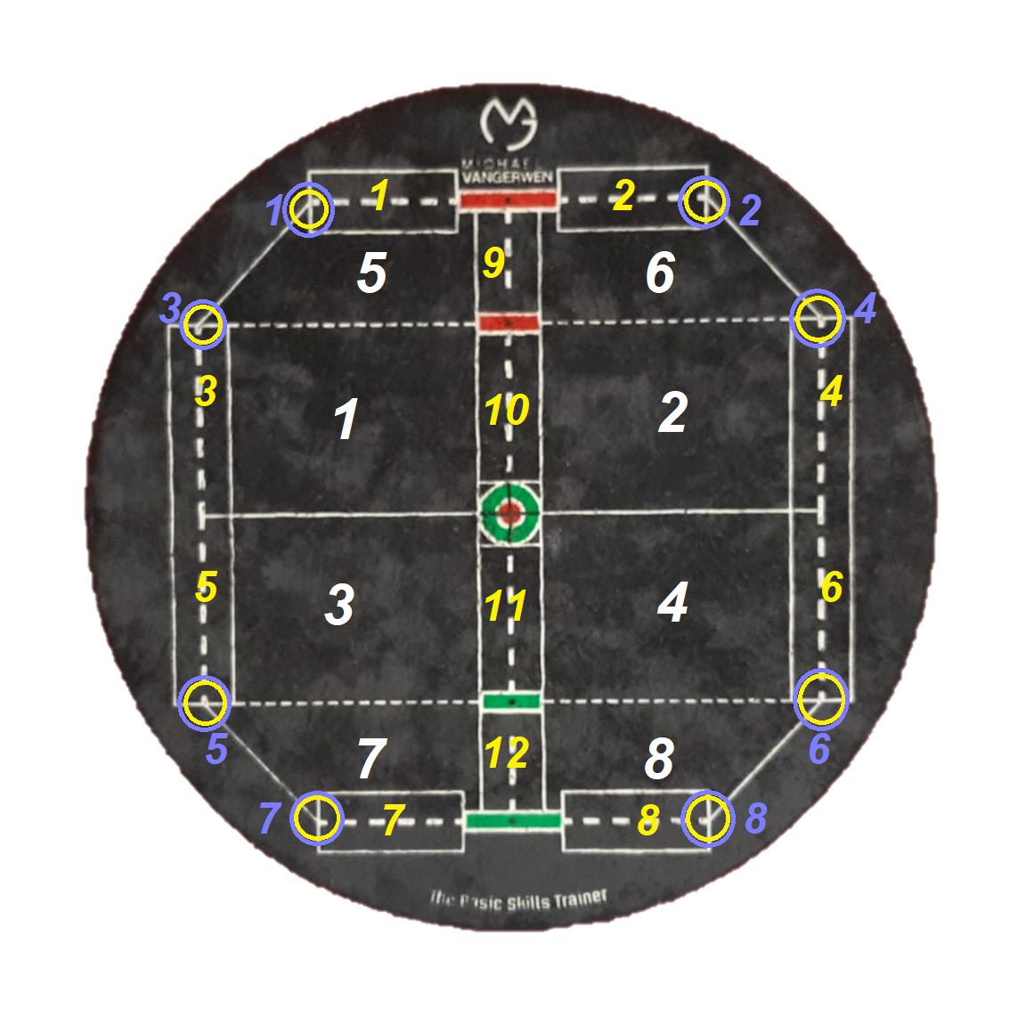

1.Werfe jeweils 3 Pfeile in die Felder der weißen Zahlen. Getroffen = 1 Punkt

|  |  |  |  |  |  |  |  |  |
| --- | --- | --- | --- | --- | --- | --- | --- | --- |
| 1 | 2 | 3 | 4 | 5 | 6 | 7 | 8 | Punkte |
|  |  |  |  |  |  |  |  |  |

2. Werfe jeweils 3 Pfeile auf die Linie der gelben Zahlen. Feld getroffen 1 Punkt Linie = 2 Punkte

|  |  |  |  |  |  |  |  |  |  |  |  |  |
| --- | --- | --- | --- | --- | --- | --- | --- | --- | --- | --- | --- | --- |
| 1 | 2 | 3 | 4 | 5 | 6 | 7 | 8 | 9 | 10 | 11 | 12 | Punkte |
|  |  |  |  |  |  |  |  |  |  |  |  |  |

3. Werfe jeweils 3 Pfeile in die Blaugelben Kreise. Überschneidungspunkt getroffen 2 Punkte. + - Im Kreis 1 Punkt

|  |  |  |  |  |  |  |  |  |
| --- | --- | --- | --- | --- | --- | --- | --- | --- |
| 1 | 2 | 3 | 4 | 5 | 6 | 7 | 8 | Punkte |
|  |  |  |  |  |  |  |  |  |